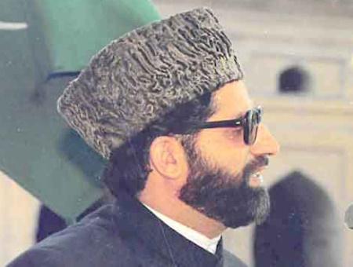**Mirwaiz Molvi Farooq**

**About:** As a matter of fact, an illustrious scion of a high-profile Mirwaiz dynasty of Kashmir, Moulvi Mohammad Farooq, happened to be an accomplished Islamic scholar and cleric who had deep understanding of the holy Quran and Ahadis. He was an outstanding orator gifted with the mellifluous voice and mesmerizing accent to deliver the sermons and speeches on the occasions of religious importance and especially in Friday congregations.

**Murdered on:** 21 May 1990.

**Attack details:**Shah was assassinated on 21 May 1990 by gunmen at his residence at Nageen, Srinagar. Hizbul Mujahideen militant Mohammad Ayub Dar was convicted for the murder and Supreme Court of India upheld the conviction in 2010.

**Reason to him target:** , [Mirwaiz Maulvi Farooq](https://en.wikipedia.org/wiki/Mirwaiz_Maulvi_Farooq) the leader of Awami Action Committee.

**Occupation:** Moulvi Mohammad Farooq, happened to be an accomplished Islamic scholar and cleric who had deep understanding of the holy Quran and Ahadis.

**Belief:** History stands an authentic and eloquent testimony to the fact that this revolutionary leader who stood deeply committed to the sublime cause of freedom was subjected to unprecedented brutalities and atrocities at the hands of the powers that be. It is pertinent to mention here that he suffered life-long hardships, prolonged incarceration and ultimately he embraced martyrdom at the hands of heartless and

diabolical forces deadly against and intrinsically antagonistic to the sublime cause of freedom and right to self- determination.

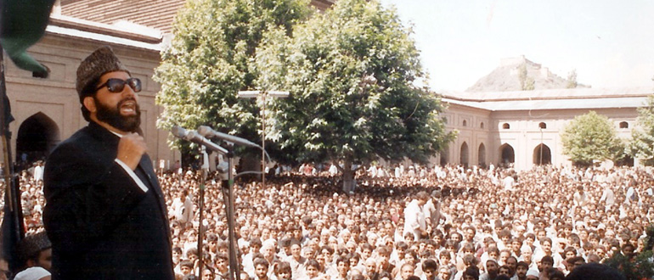**URL :** [https://wilayattimes.com/late-mirwaiz-molvi-farooqa-glowing-tribute-to-charismat ic-leader-and-great-revolutionary/](https://wilayattimes.com/late-mirwaiz-molvi-farooqa-glowing-tribute-to-charismat%20ic-leader-and-great-revolutionary/)